

**DV1C04 AY2022 TERM 1**

**Individual Coursework 1 Submission**

|  |  |
| --- | --- |
| **Personal Details** | |
| **Name** |  |
| **Student No.** |  |

|  |  |  |
| --- | --- | --- |
| **Compliance Statement** | | |
| **Plagiarism**  I declare that this assignment is my original work. I understand that if I am suspected of plagiarism, my enrolment in the programme may be terminated. | | **🗸** |
| **Retention of Backup Copy**  I declare that I have a back-up electronic copy of this report for immediate submission. | | **🗸** |
| **Signature** |  | |
| **IMPORTANT:** Non-compliance to these clauses will result in unconditional rejection of your submission | | |

Instruction to the Candidate

This coursework assignment is an individual graded assignment. The assignment must to be completed and submitted by each candidate.

1. **Upload your completed assignment to SA2.0 as shown in the screen shot below. Access** [***https://mysa.rp.edu.sg***](https://mysa.rp.edu.sg/)***,* enter your RP Student ID and Password, and click LOGIN.**

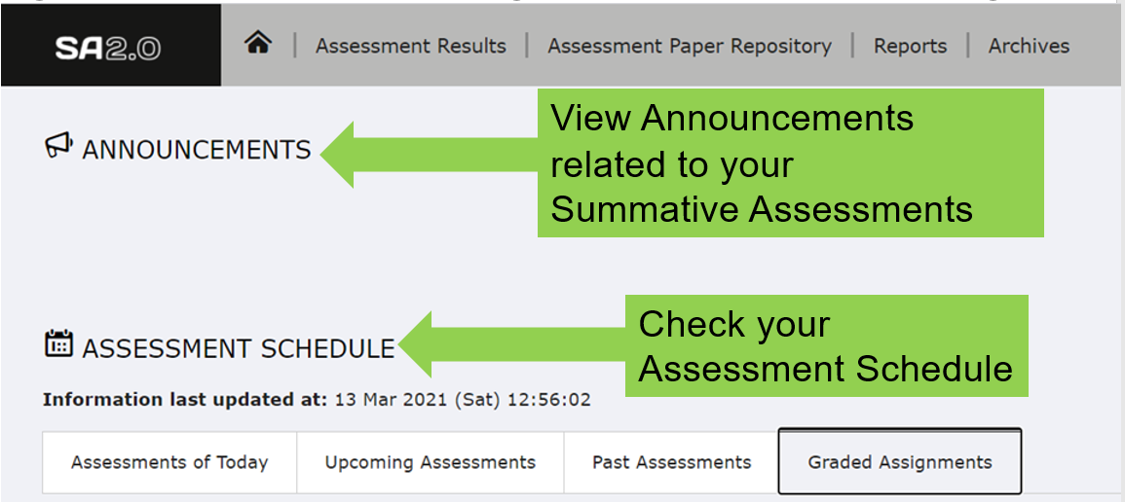

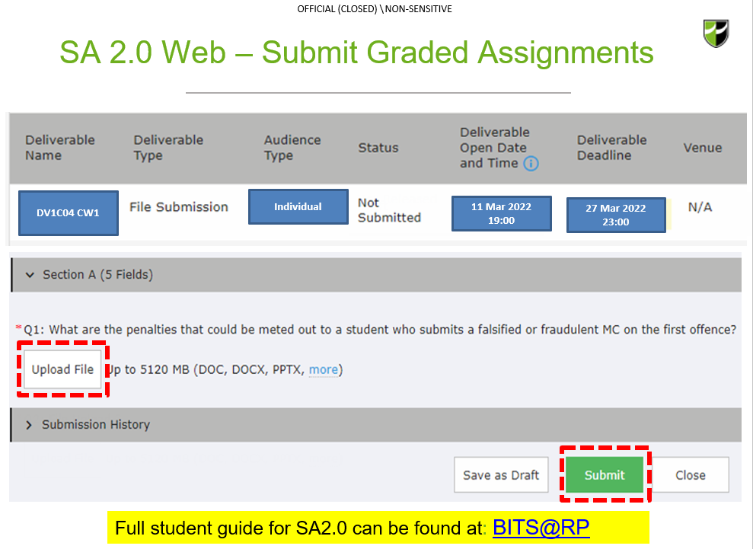

Full student guide for SA2.0 can be found at:[**BITS@RP**](https://myrp.sharepoint.com/:b:/r/sites/SA/User%20Guide/Republic%20Polytechnic%20SA%202.0%20Student%20User%20Guide%20v2.0_Final.pdf?csf=1&web=1&e=xNH3Kp)

1. **Please note the deadline for your assignment submission is 27th March 2022, 23:00 on SA2.0.**

**Submission Procedures**

1. Candidate must produce an assignment using this **DV1C04** Coursework 1 Graded Assignment Template
2. All sections in the template MUST be completed
3. All font, header, footer, margin, page layout settings must be followed
4. Candidate is to upload his/her assignment to SA2.0. in **one** file  
   - **candidate’s assignment**
5. For the submission to SA2.0, the completed assignment file must be saved in PDF format with the following file naming convention:

<Student ID>-<Name>-DV1C04-AY2022CW1.pdf

e.g. 21012345-John Khoo- DV1C04-AY2022CW1.pdf

1. Candidate must submit his/her final completed assignment to the Programme Co-ordinator no later than **2300h** on **27th Mar 2022 to SA2.0**. Late submissions of assignment-based coursework component without leave of absence (LOA) for the module will be subjected to the following late penalty:



1. Candidate is expected to produce his/her own assignment. Any copying of other’s assignment will be reported and dealt with.

**Next Page is the start of Assignment**



graded Assignment

<Module Code> <Module Name>

Date of Submission: DD-MMM-YYYY

Submitted By:

|  |  |
| --- | --- |
| <student_id> | <student_name> |
|  |  |
|  |  |
|  |  |

**This graded assignment has a maximum of 40 marks.**

From your machine logged-in to RP VPN, run Remote Desktop Connection to connect to the ubuntu Linux Virtual Machine (VM). Please login based on your assigned VM as shown below:

|  |  |  |  |  |  |
| --- | --- | --- | --- | --- | --- |
| **S/N** | **Name** | **VM** | **IP Address** | User Name | Password |
| 1 | LEOW TANG QING | Ubuntu-01 | 172.20.113.160 | dockeradm | docker!2 |
| 2 | LIM SHEN HUI | Ubuntu-02 | 172.20.113.161 | dockeradm | docker!2 |
| 3 | LIN JINGZHOU | Ubuntu-03 | 172.20.113.162 | dockeradm | docker!2 |
| 4 | MUHAMMAD FAISAL BIN SHAIK HASSAN | Ubuntu-04 | 172.20.113.163 | dockeradm | docker!2 |
| 5 | LYNN LEE QING XIA | Ubuntu-05 | 172.20.113.164 | dockeradm | docker!2 |
| 6 | NG CHEE KIONG | Ubuntu-06 | 172.20.113.165 | dockeradm | docker!2 |
| 7 | PARAMASIVAM S/O VANNU GOPAL | Ubuntu-07 | 172.20.113.166 | dockeradm | docker!2 |
| 8 | SAHLATUL-FARIHAH BINTE M ASARI | Ubuntu-08 | 172.20.113.167 | dockeradm | docker!2 |
| 9 | SHAIKH FAID BIN OMAR | Ubuntu-09 | 172.20.113.168 | dockeradm | docker!2 |
| 10 | CHIU JING XIONG | Ubuntu-10 | 172.20.113.169 | dockeradm | docker!2 |
| 11 | KELLY WONG XUE YEE | Ubuntu-11 | 172.20.113.170 | dockeradm | docker!2 |
| 12 | LIM SI YING | Ubuntu-12 | 172.20.113.171 | dockeradm | docker!2 |
| 13 | LIN LI YI | Ubuntu-13 | 172.20.113.172 | dockeradm | docker!2 |
| 14 | MUHAMMAD MUQTADIR BIN SADIQ BASHA | Ubuntu-14 | 172.20.113.173 | dockeradm | docker!2 |
| 15 | NUR HIDAYAH BTE RAMLEE | Ubuntu-15 | 172.20.113.174 | dockeradm | docker!2 |
| 16 | NUR NADIA ASHBOLLAH BINTE | Ubuntu-16 | 172.20.113.175 | dockeradm | docker!2 |
| 17 | NUR THAQIFAH AQILAH BINTE JURAIMI | Ubuntu-17 | 172.20.113.176 | dockeradm | docker!2 |
| 18 | RAUDHATUNNISHA BTE RAMLI | Ubuntu-18 | 172.20.113.177 | dockeradm | docker!2 |
| 19 | SITI NUR ALYSHYIA BINTE HASHIM | Ubuntu-19 | 172.20.113.178 | dockeradm | docker!2 |
| 20 | TAN TEE BING | Ubuntu-20 | 172.20.113.179 | dockeradm | docker!2 |

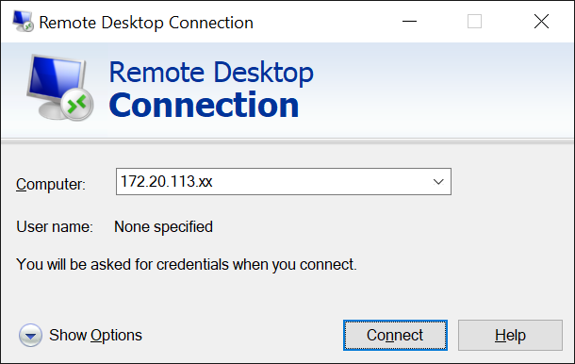

Replace **xx** with the IP address of the VM that you have been assigned.

1. Change the password for the user account **dockeradm** to “Your Student ID”. (**0 mark)**

**# passwd**

1. a) Configure the hostname (computer name) of your VM according to the following naming convention. Take a screenshot of output to reflect the new hostname.   
     
   VM-**XXXXXXXX** (**XXXXXXXX**: Your student ID, Example: **VM-210123456**) **(2 marks)**

|  |
| --- |
|  |

b) Add a new domain name of **puppetserver.dv1c04-XXXXXXXX.com** that maps **127.0.0.1** in your VM. **Ping** [**puppetserver.dv1c04-XXXXXXXX.com**](http://www.dv1c04.com). Take a screenshot of ping output to show the newly added domain name.

**puppetserver.dv1c04-****XXXXXXXX.com** (***XXXXXXXX****: Your student ID,* *Example:* ***puppetserver.dv1c04-210123456.com***)

(**2 marks**)

|  |
| --- |
|  |

1. Install Puppet Enterprise (PE) on your VM. Upon end of installation, access the PE console at **http://172.20.113.xx** using web browser which **172.20.113.xx** is the IP address of your VM. Take a screenshot of the output. (**5 marks**)

|  |
| --- |
|  |

1. Install Puppet Agent on a Docker container. The Docker container should have a hostname of **puppetclient.XXXXXXXX.com** which **XXXXXXXX** is your student ID.   
     
   Run command **puppet agent -tv** on the container to show the working connectivity between the agent and master. Take a screenshot of the output. **(5 marks)**

|  |
| --- |
|  |

1. Issue the **COMPLETE** command on the Puppet master to view all **signed** certificates? Take a screenshot of the command of the output. **(2 marks**)

|  |
| --- |
|  |

1. Identify the missing parts of the command below based on the given output. **(2 marks)**  
     
   

|  |
| --- |
|  |

1. Explain in details what do the following Puppet codes do? **(3 marks**)  
     
   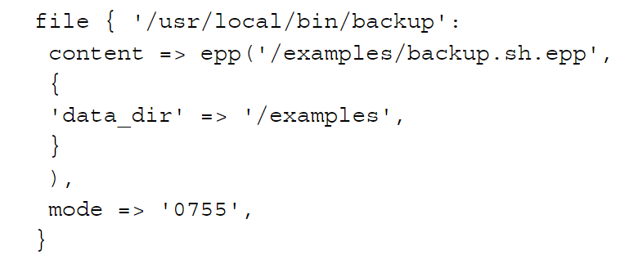

|  |
| --- |
|  |

1. Identified **THREE (3)** syntax errors from the following class definition. **(3 marks**)  
     
   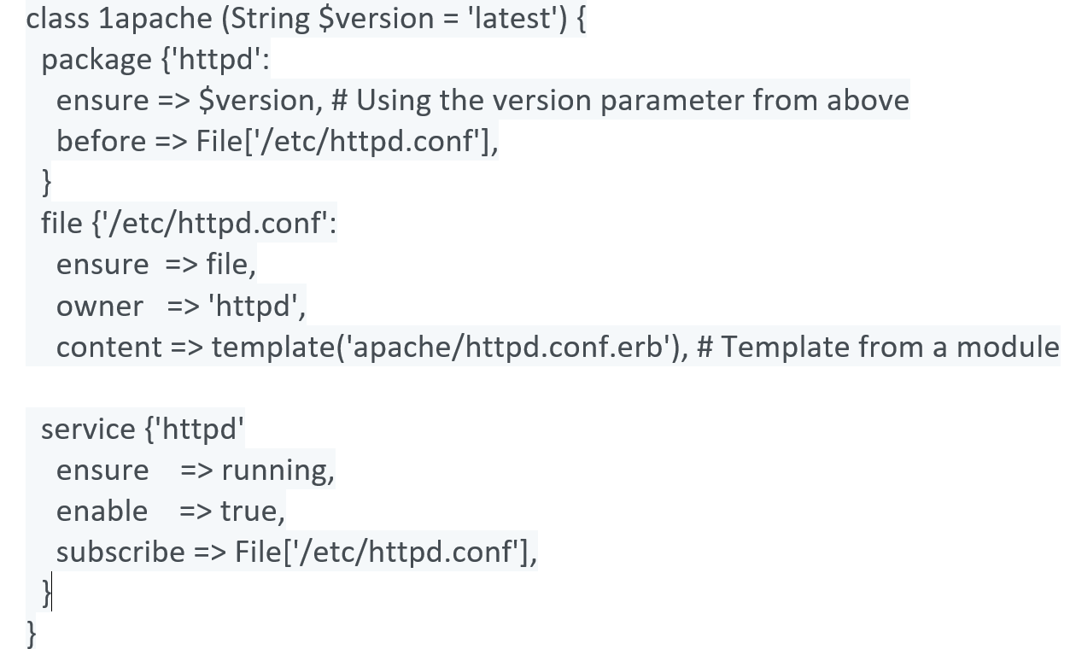

|  |
| --- |
|  |

1. Among the five deployment strategies, which **ONE** of them will result in deployment downtime of the service and a full reboot cycle is executed? **(1 mark**)

|  |
| --- |
|  |

1. In Puppet, what port is used by the primary server to accept inbound traffic/requests from agent? (**1 mark**)

|  |
| --- |
|  |

1. a) Create a puppet code (**test.pp**) to create a test file named **“testfile”** under a directory named “**testdir**” under the path **/var/tmp/** with owner **“nicholas”** and group **“nicholas”**. The owner has all the permissions to read, write and execute of the file while everyone else can read and execute but cannot make changes.

Take a screenshot of the content of the created **test.pp**. (**5 marks**)

|  |
| --- |
|  |

b) Issue the **COMPLETE COMMAND** to validate the syntax of the **test.pp**. Take a screenshot of the output. (**2 marks**)

|  |
| --- |
|  |

1. Create a puppet code (**init.pp**) with a class definition “**chrony**” to make sure the package "**chrony**" is installed, ensure the service is running and auto-starts. The service must also be restarted if the “**/etc/chrony.conf”** changes. Take a screenshot of the content of the created **init.pp**. **(7 marks**)

|  |
| --- |
|  |

**End of Assignment**